Cassandra Exercise - 1

Considering the database schema displayed in the diagram below,

1. Write a CQL query to create 10 invoices and return a list of all the invoices. For each invoice, show the Invoice ID, the billing date, the customer’s name, and the name of the customer who referred that customer (if any).
2. The list should be ordered by billing date.

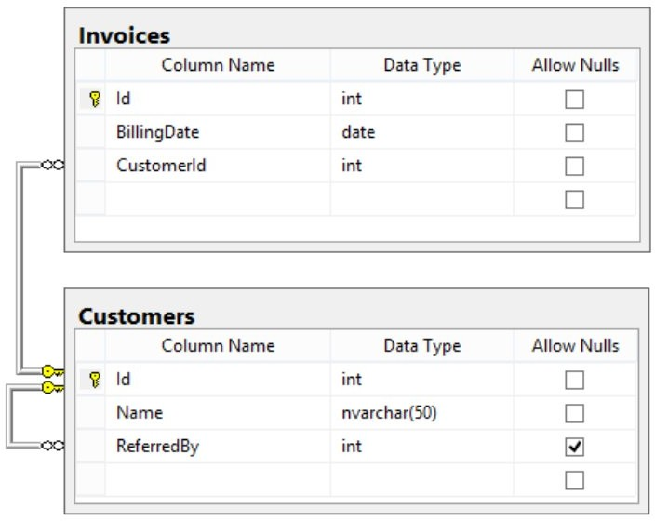

1. Create Customers list based on id(unique key)
2. Retrieve the customer details based on Mobile Number(index)
3. Create a simple Cassandra cluster with 3 nodes

[https://www.jamescoyle.net/how-to/2448-create-a-simple-cassandra-](http://www.jamescoyle.net/how-to/2448-create-a-simple-cassandra-) cluster-with-3-nodes